4CONGRUENT TRIANGLES
Pearson Edexcel - Tuesday 19 May 2020 - Paper 1 (Non-Calculator) Higher Tier
1.
Pearson Edexcel - Tuesday 11 June 2019 - Paper 3 (Calculator) Higher Tier
2.
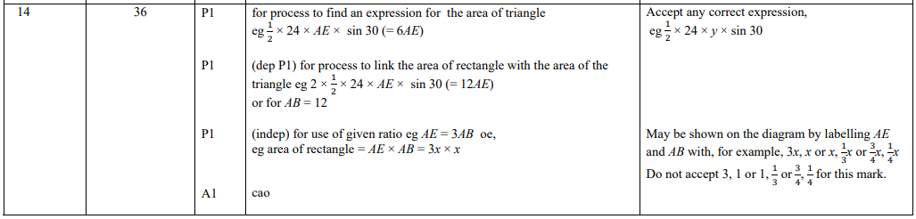
Pearson Edexcel - Tuesday 12 June 2018 - Paper 3 (Calculator) Higher Tier
3.
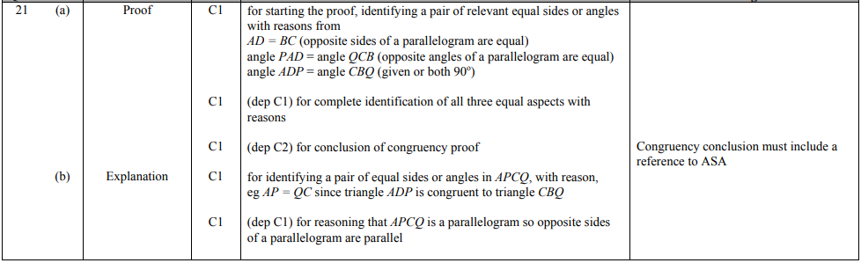
Pearson Edexcel - Specimen Papers Set 2 - Paper 1 (Non-Calculator) Higher Tier
4.
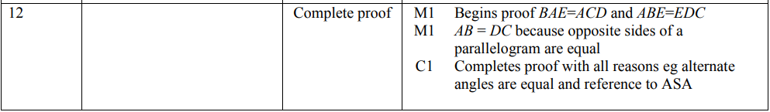
Pearson Edexcel - Specimen Papers Set 1 - Paper 1 (Non-Calculator) Higher Tier
5.
Pearson Edexcel - Sample Paper 3 - (Calculator) Higher Tier
6.
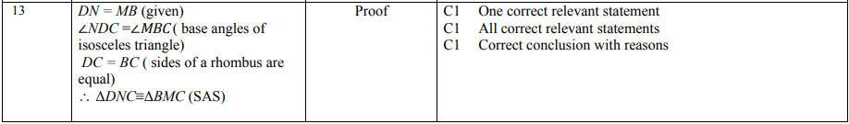
Pearson Edexcel - Friday 8 November 2013 - Paper 2 (Calculator) Higher Tier
7.
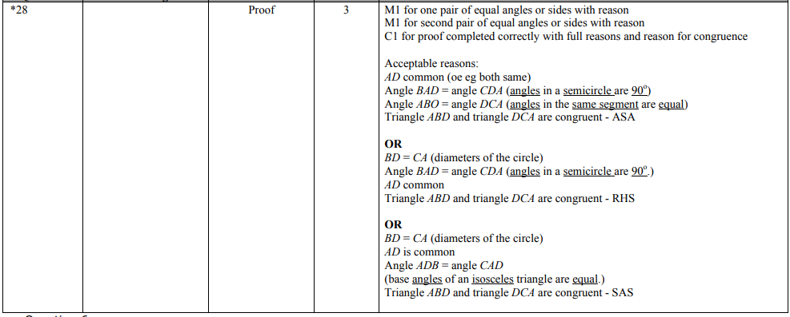
Pearson Edexcel - Monday 14 November 2011 - Paper 4 (Calculator) Higher Tier
8.
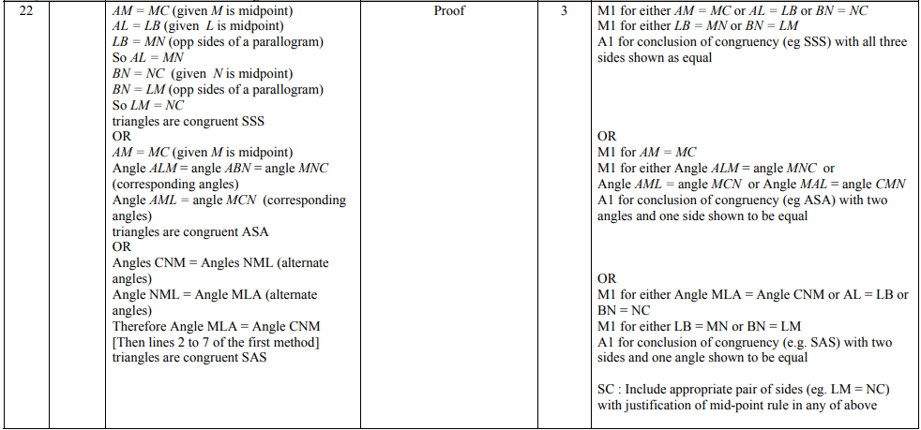
OCR GSCE – Thursday 5 November 2020 – Paper 5 (Non-Calculator) Higher Tier
9.
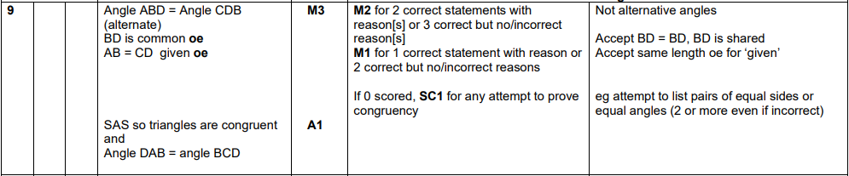
OCR GSCE – Tuesday 5 November 2019 – Paper 6 (Calculator) Higher Tier
10.
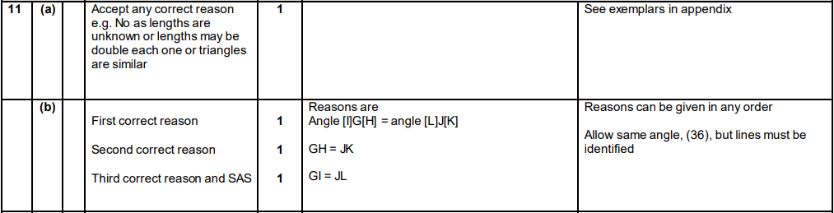

OCR GSCE – Tuesday 12 June 2018 – Paper 6 (Calculator) Higher Tier
11.
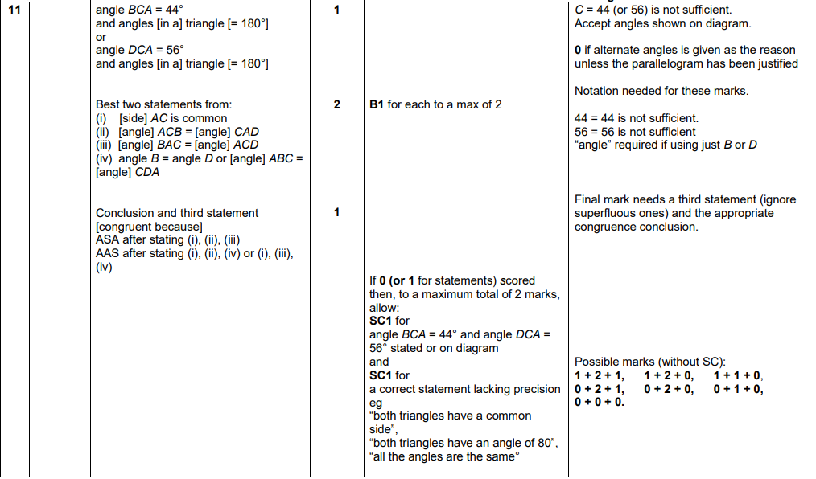
OCR GSCE – Tuesday 6 November 2017 – Paper 5 (Non - Calculator) Higher Tier
12.
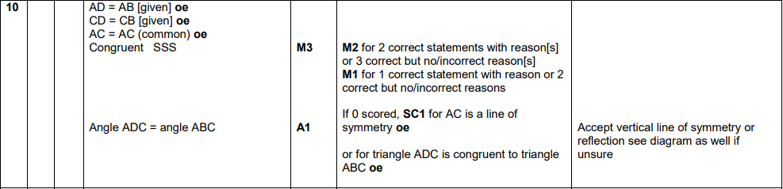

OCR GSCE – Tuesday 13 June 2017 – Paper 6 (Calculator) Higher Tier
13.
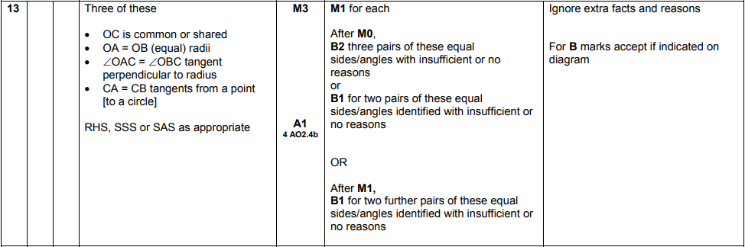
OCR GSCE – Sample Papers – Paper 4 (Calculator) Higher Tier
14.
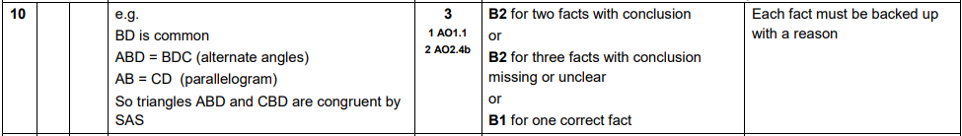
AQA GSCE – Thursday 4 June 2020 – Paper 2 (Calculator) Higher Tier
15.
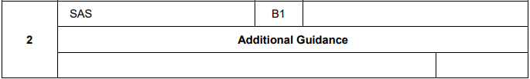

AQA GSCE – Tuesday 21 May 2019 – Paper 1 (Non - Calculator) Higher Tier
16.
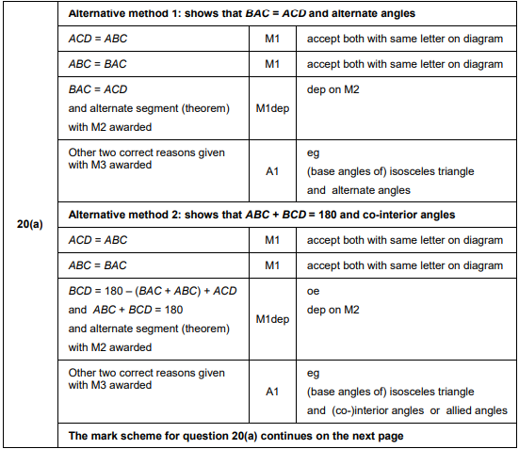
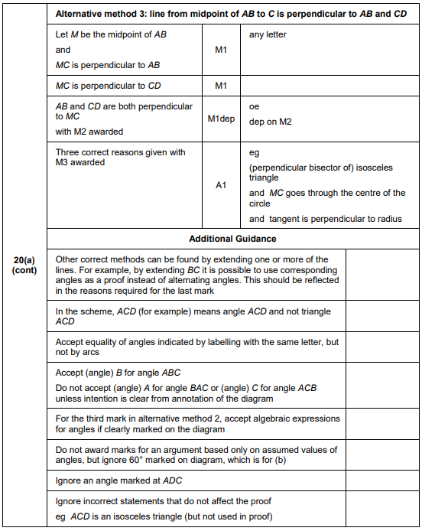
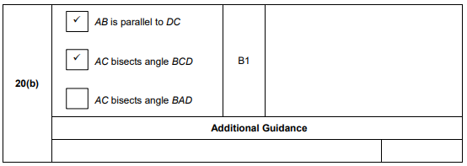
AQA GSCE – Tuesday 6 November 2018 – Paper 1 (Non - Calculator) Higher Tier
17.
AQA GSCE – Wednesday 25 May 2017 – Paper 1 (Non - Calculator) Higher Tier
18.
AQA GSCE – Tuesday 13 June 2017 – Paper 3 (Calculator) Higher Tier
19.
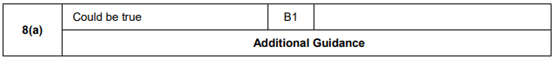
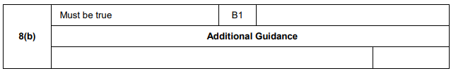
AQA GSCE – Sample Paper 2 (Calculator) Higher Tier
20.

